Union-Find variants and Kruskal's algorithm
Track A empirical study. 41052 Advanced Algorithms, Spring 2026.

(a) What I built
I implemented a disjoint-set Union-Find and Kruskal's algorithm for the minimum spanning tree of an undirected weighted graph.
Union-Find lives in include/union_find.hpp and src/union_find.cpp. Each element stores a parent index. The rank variant also stores a rank. There are three variants, selected by an enum so the same Kruskal code can be timed against each of them:
- Naive. find walks parent pointers and does not change them. unite always hangs the second root under the first.
- Path compression. find points every node on the path at the root. unite still always hangs the second root under the first.
- Rank. Path compression, plus union by rank: the root with smaller rank is hung under the other, and rank increases by one when the ranks were equal.
Kruskal is in src/kruskal.cpp. It sorts a copy of the edge list by weight and then scans that list, calling unite and keeping an edge when unite returns true. It stops after n - 1 accepted edges. kruskalMstWeightSorted is the same scan without the sort, so the benchmark can time the sort and the Union-Find scan separately.
Graph generators are in src/graph.cpp.
- randomGraph builds an undirected simple graph with exactly m edges. Weights are integers drawn uniformly from 1 to 1,000,000.
- gridGraph builds a side by side grid. Every edge weight is 1, so n = side * side and m is about 2n.
- completeGraph builds K_n with every weight equal to 1.
The benchmark driver is bench/bench_main.cpp. It writes one CSV row per configuration: benchmark name, variant, graph family, n, m, median of 10 timed runs, run count, and seed. One untimed call is made before those 10 runs. Plots are produced by bench/plot_results.py.
I used C++23 and g++ 13.2.0 with -O2. Parents and ranks are std::vector<int>. There is no library disjoint-set type in the project, because the comparison is between these three linking rules. Kruskal only needs a sort and a scan, so the MST path does not build an adjacency list.
Tests in tests/test_union_find.cpp check that all three variants agree on a 5-vertex union sequence, on a triangle whose MST weight is 3, and on the 7-vertex lecture graph whose MST weight is 27.

(b) Empirical study

What I compared
The baseline is the naive Union-Find. The other two variants are path compression alone, and path compression with union by rank.
I compared them in two places.
- A random sequence of m = 4n unite calls, each followed by two find calls, for n in {500, 1000, 2000, 5000, 10000}.
- Full Kruskal on three graph families: random graphs with m = 2n, grid graphs, and complete graphs. For Kruskal I recorded wall time of kruskalMstWeight (copy, sort, and scan), and also the sort and the Union-Find scan on their own.

Hypotheses
Before looking at the tables below, I expected three things.
- On the long unite sequence, naive linking would be much slower than either compressed variant once n was in the thousands. I did not expect a large gap between the two compressed variants.
- Path compression alone would be close to rank on random unions, with rank only a bit faster, because compression already stops long chains from surviving.
- Inside Kruskal, the largest gap between variants would be on complete graphs, because those have the most edges.

How I measured
Machine: AMD Ryzen 7 6800H. Compiler: g++ 13.2.0, -O2, C++23. Seed 42 for every random input. Each number below is the median of 10 runs after one warmup call, taken from results/results.csv. Times in the tables are milliseconds, rounded from the nanosecond medians.
The grid and complete generators use weight 1 on every edge. std::sort is not stable, so I did not control the order of equal-weight edges. The scan stops once n - 1 edges have been accepted. I did not count how many edges were examined before that stop.

Results

Random unite sequence (m = 4n).
See results/uf_variants.png and results/uf_variants_log.png.
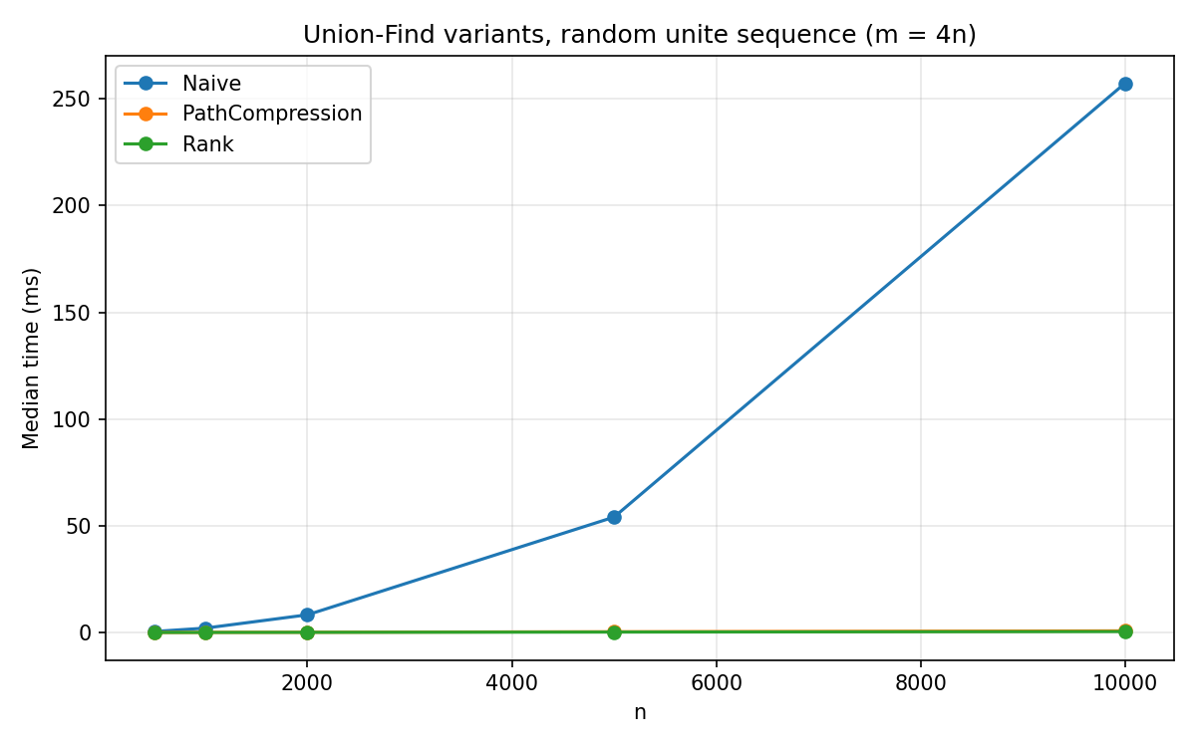
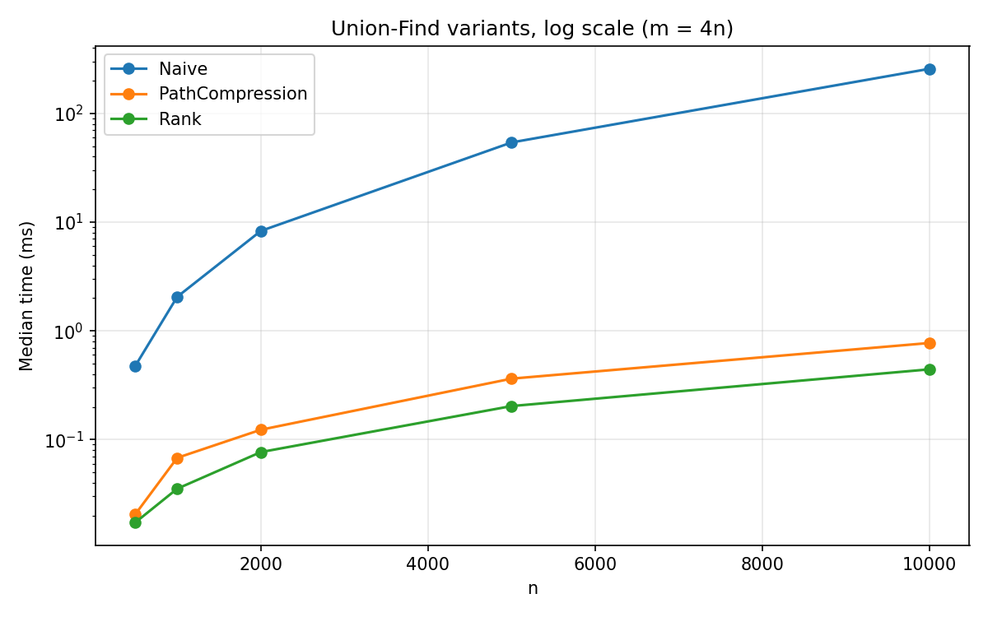
n | Naive (ms) | Path compression (ms) | Rank (ms) | Naive / rank
500 | 0.477 | 0.0206 | 0.0173 | 27.6
1000 | 2.054 | 0.0679 | 0.0353 | 58.2
2000 | 8.293 | 0.123 | 0.0767 | 108
5000 | 54.07 | 0.363 | 0.203 | 266
10000 | 257.3 | 0.774 | 0.443 | 581
On the linear plot the two compressed lines sit on the axis, because naive reaches 257 ms. The log plot is the one that separates them. All three lines rise. Naive is steeper. Path compression stays above rank the whole way.
From n = 1000 to n = 10000 the operation count grows by 10 times. Naive time grows from 2.054 ms to 257.3 ms, which is 125 times. Rank grows from 0.0353 ms to 0.443 ms, which is 12.5 times. Path compression takes longer than rank at every n in this table. The ratio is 1.19 at n = 500 (0.0206 / 0.0173) and between 1.60 and 1.92 after that. At n = 10000 it is 1.75 (0.774 / 0.443).

Kruskal on random graphs (m = 2n).
Wall time is results/kruskal_random.png. The Union-Find scan alone is results/kruskal_uf_random.png. Sort time is results/kruskal_sort_random.png.
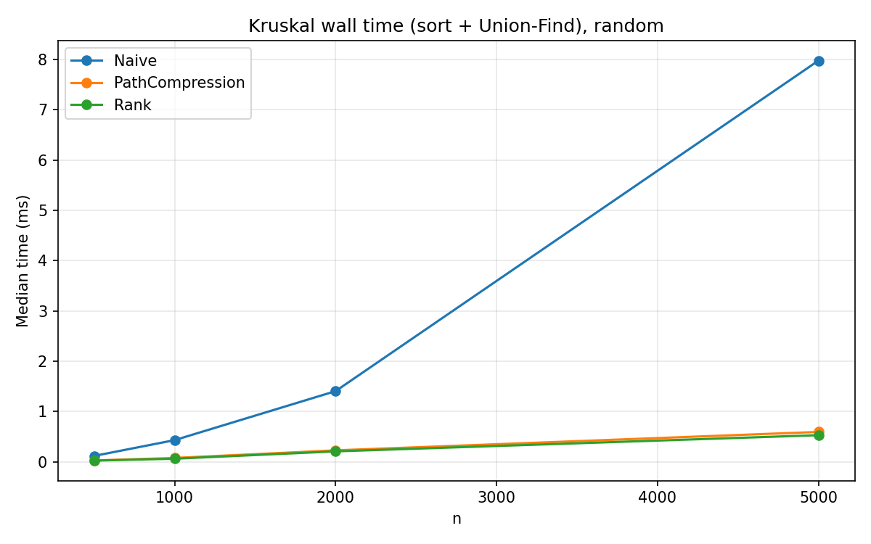
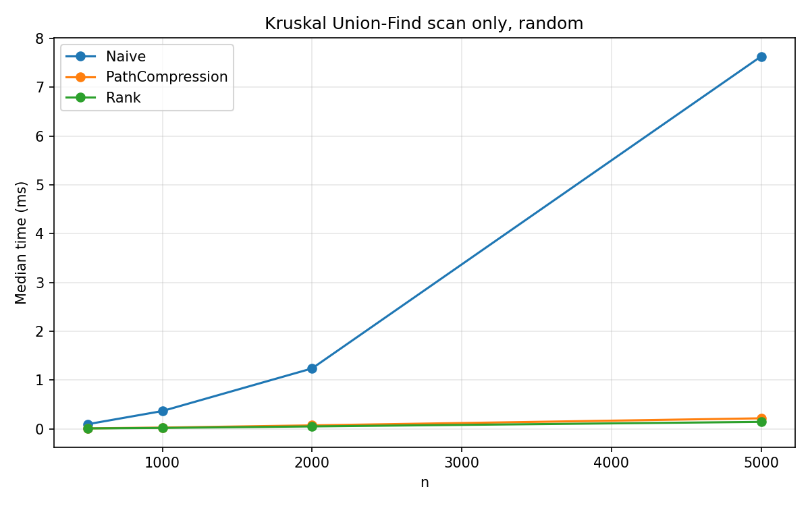
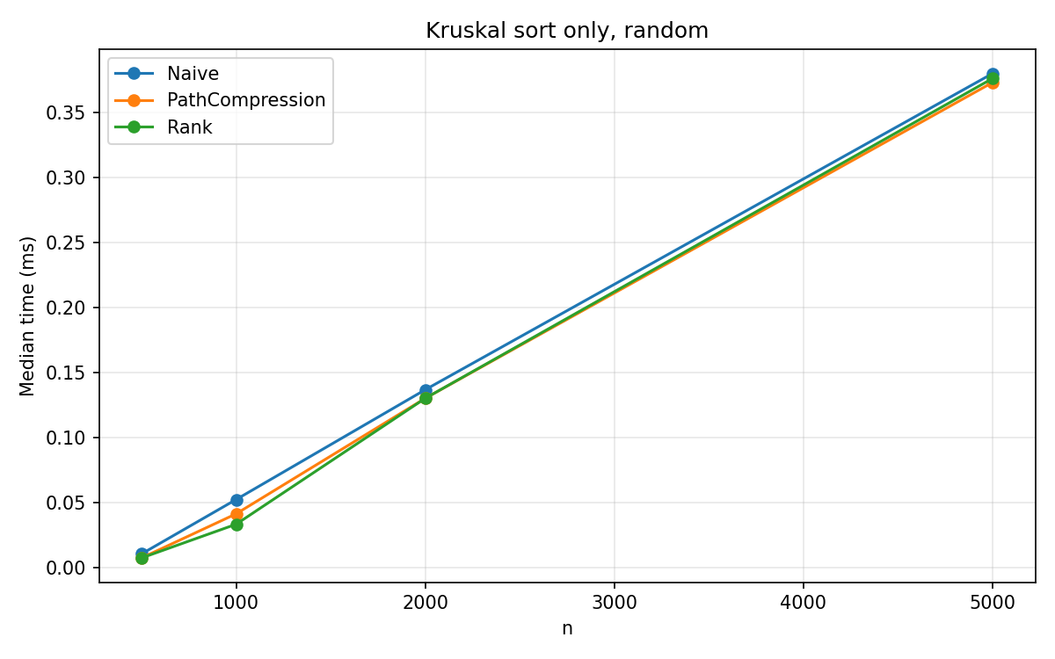
n | m | Naive total | Rank total | Naive UF scan | Rank UF scan | Sort (rank row)
500 | 1000 | 0.115 | 0.0224 | 0.0931 | 0.0070 | 0.0077
1000 | 2000 | 0.429 | 0.0600 | 0.363 | 0.0172 | 0.0336
2000 | 4000 | 1.404 | 0.206 | 1.237 | 0.0482 | 0.130
5000 | 10000 | 7.978 | 0.528 | 7.634 | 0.142 | 0.376
At n = 5000 the three sort medians are 0.380 ms (naive), 0.373 ms (path compression) and 0.376 ms (rank). At n = 1000 they are further apart: 0.0526, 0.0416 and 0.0336 ms. The sort does not call Union-Find. That spread is timing noise on a short sort. By n = 2000 the three sort medians are 0.137, 0.130 and 0.130 ms.
For rank at n = 5000, the sort (0.376 ms) is longer than the Union-Find scan (0.142 ms). For naive, the scan is 7.634 ms and the sort is 0.380 ms, so the wall time (7.978 ms) is mostly the scan. Naive / rank wall time at this point is 7.978 / 0.528 = 15.1.
Path compression on the same scan is 0.214 ms, which is 1.52 times the rank scan (0.142 ms).

Kruskal on grids.
All weights are 1. The plots are results/kruskal_grid.png and results/kruskal_uf_grid.png. The series jumps around, so the medians are listed below.
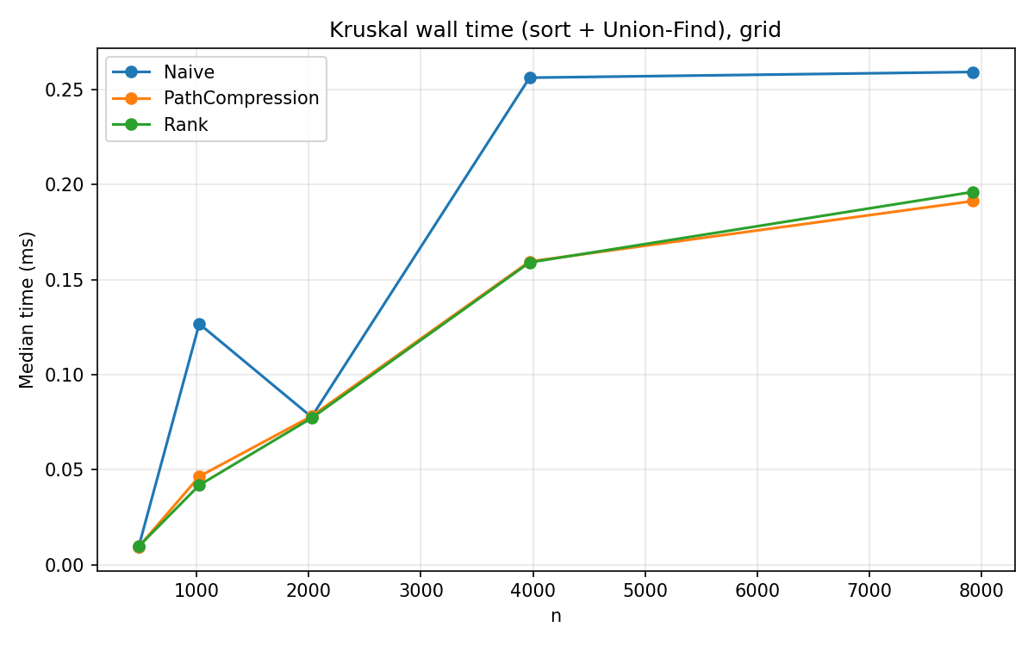
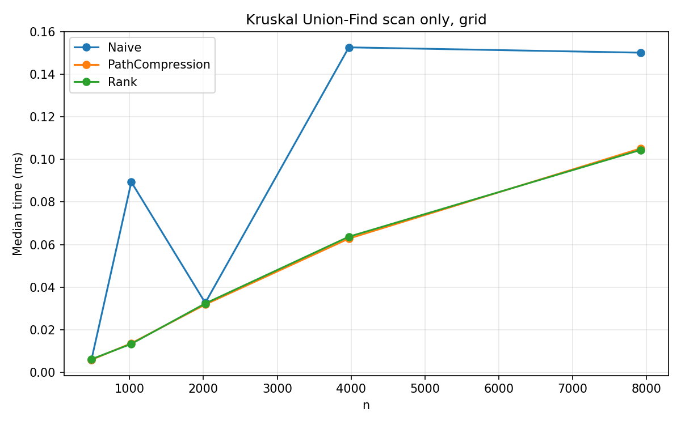
n | side | m | Naive wall | Path compression wall | Rank wall | Naive scan | Rank scan
484 | 22 | 924 | 0.0095 | 0.0094 | 0.0097 | 0.0058 | 0.0061
1024 | 32 | 1984 | 0.127 | 0.0465 | 0.0419 | 0.0894 | 0.0133
2025 | 45 | 3960 | 0.0778 | 0.0782 | 0.0772 | 0.0326 | 0.0323
3969 | 63 | 7812 | 0.256 | 0.160 | 0.159 | 0.153 | 0.0637
7921 | 89 | 15664 | 0.259 | 0.191 | 0.196 | 0.150 | 0.105
At n = 484 the three wall times agree to about 0.0003 ms. At n = 1024 naive jumps to 0.127 ms while rank is 0.0419 ms (ratio 3.03). The scan ratio there is 0.0894 / 0.0133 = 6.72. At n = 2025 the three wall times are back together (0.0778, 0.0782, 0.0772) and the scans are 0.0326, 0.0318 and 0.0323 ms. At n = 3969 naive wall time is 0.256 ms against 0.159 ms for rank (ratio 1.61), and the scan ratio is 0.153 / 0.0637 = 2.40. At n = 7921 naive wall time is 0.259 ms, almost the same as at n = 3969, while path compression and rank have risen to 0.191 ms and 0.196 ms. The scan ratio there is 0.150 / 0.105 = 1.44.
The largest grid in the run is therefore not the largest gap. The 32 by 32 grid has the biggest naive/rank ratio in this family, and the next size wipes it out. I would not treat the n = 1024 point as a stable crossover.

Kruskal on complete graphs.
All weights are 1. Plots: results/kruskal_complete.png, results/kruskal_uf_complete.png, results/kruskal_sort_complete.png.
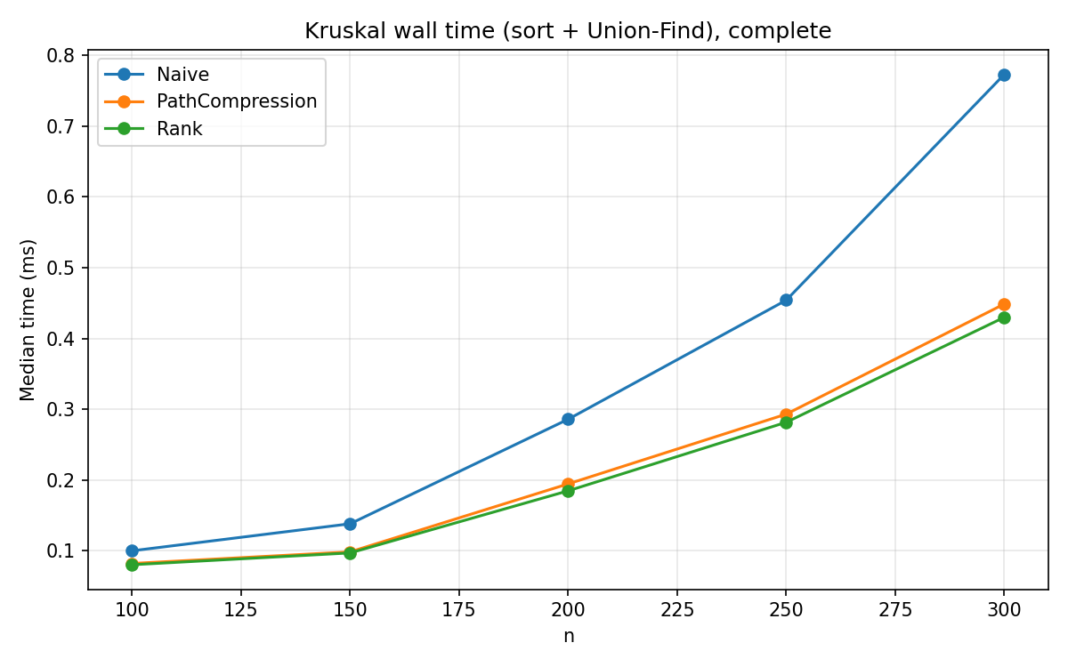
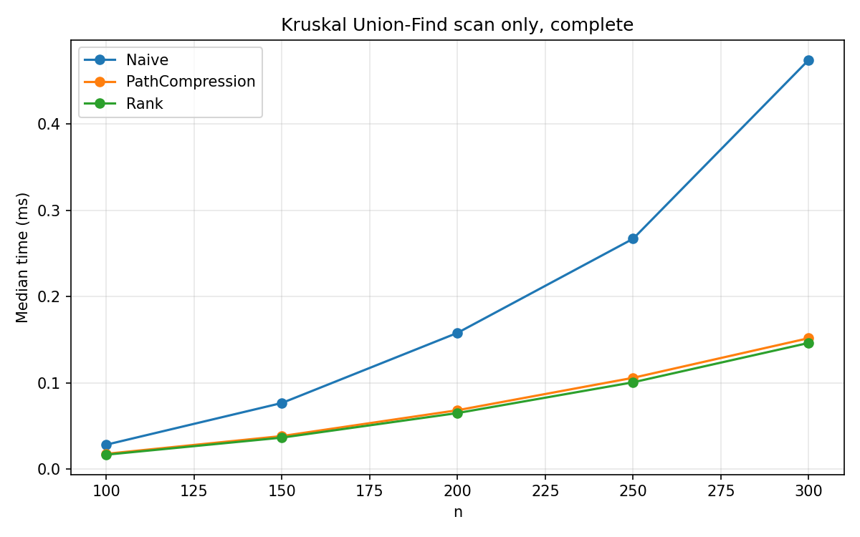
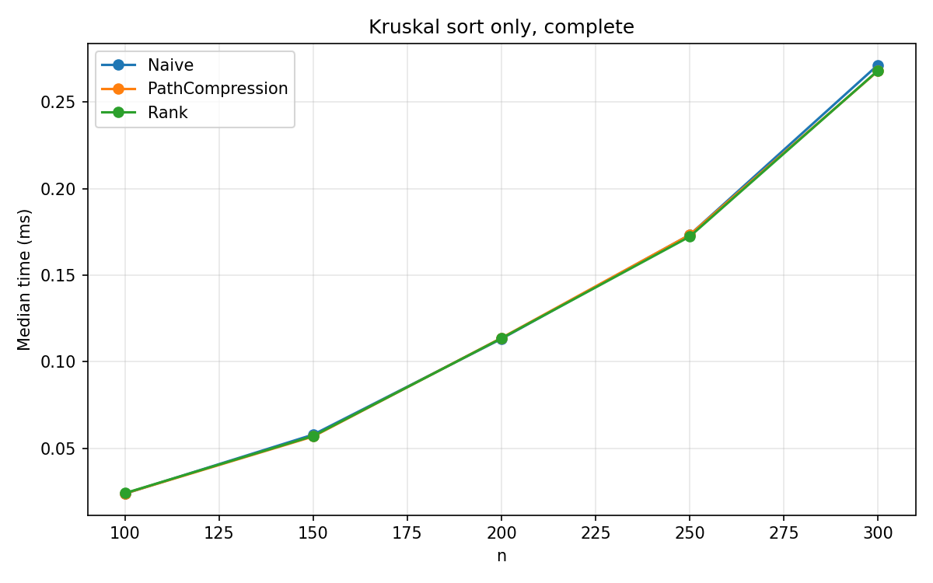
At n = 300 (m = 44850) the wall times were 0.773 ms (naive), 0.449 ms (path compression) and 0.430 ms (rank). Naive / rank wall time is 0.773 / 0.430 = 1.80. The sort medians were 0.271, 0.268 and 0.268 ms. The Union-Find scans were 0.475, 0.152 and 0.146 ms, so the scan ratio is 0.475 / 0.146 = 3.25, larger than the wall-time ratio, because the sort is a big share of the rank run (0.268 ms of 0.430 ms). Path compression and rank differ by about 4% on both the wall time (0.449 / 0.430 = 1.04) and the scan (0.152 / 0.146 = 1.04).

Analysis
Hypothesis 1 holds on the unite sequence. Naive is slower at every n, and the ratio grows from 28 times at n = 500 to 581 times at n = 10000. The linear plot hides the compressed variants. The log plot shows they still get slower as n grows, just much more slowly than naive.
Hypothesis 2 holds in the narrow sense. Rank is faster than path compression on every unite-sequence row, but the factor is 1.19 to 1.92, not an order of magnitude. On the random-graph Kruskal scan at n = 5000 the factor is 1.52. On the complete graph at n = 300 it is 1.04. On the 89 by 89 grid the two compressed scans are 0.1052 ms and 0.1045 ms. I cannot see an inverse-Ackermann curve in these timings. Both compressed variants are already short enough that, once a sort is in the measurement, the sort can be the longer part.
Hypothesis 3 does not hold. Ranking the largest run of each family by naive/rank wall time:
Family | Size used | Naive / rank wall time
Unite sequence | n = 10000, m = 40000 | 581
Random Kruskal | n = 5000, m = 10000 | 15.1
Complete Kruskal | n = 300, m = 44850 | 1.80
Grid Kruskal | n = 7921, m = 15664 | 1.32
The complete graph has the most edges and one of the smaller gaps. The random graph, with only m = 2n, has the larger Kruskal gap. The unite benchmark, which has no sort and no early exit, has the largest gap of all.
The implementation does stop after n - 1 accepted edges, so the complete-graph scan is not required to read all 44,850 edges. I did not log the number of edges actually read, so I am not claiming a measured early-exit count. What I did measure is the split of time: at n = 300, rank spends 0.268 ms sorting and 0.146 ms in the Union-Find scan.
The grid plot is a warning about reading one median as a law. Naive wall time falls from 0.127 ms at n = 1024 to 0.0778 ms at n = 2025, then rises to 0.256 ms and stays at 0.259 ms. Those are the medians in the CSV. Equal edge weights make the sort order unstable, and several of these runs are under 0.1 ms, so a single spike can move the median.
Rank was the fastest variant on the unite sequence and on the random and complete Kruskal runs. On the grids the two compressed variants trade places by a few microseconds. At n = 7921, rank wall time is 0.196 ms and path compression is 0.191 ms.

(c) What I learned
I expected the complete graphs to be the hard case, because they have the most edges and the Kruskal bound is usually written as O(m log m). The wall-time ratios went the other way. At n = 5000 on a random graph with m = 10000, rank spends 0.376 ms sorting and 0.142 ms linking. The naive scan on that same graph is 7.634 ms. On the complete graph at n = 300, rank's sort (0.268 ms) is again longer than its scan (0.146 ms), and the naive/rank wall-time ratio is only 1.80.
The size of the naive penalty on the plain unite sequence was the other surprise. At n = 10000 and 40,000 operations, naive took 257.3 ms and rank took 0.443 ms. Both measurements use the same loop. The linking rule is what changed.
The grid plot is the result I would have misread if I had only quoted the largest n. The 89 by 89 grid is a 1.32 wall-time ratio. The 32 by 32 grid is a 3.03 ratio, and the 45 by 45 grid is a 1.01 ratio. The spike is visible in results/kruskal_grid.png: naive rises, drops back onto the other two lines, then rises again and flattens. I do not have an explanation for that drop that I can check from the CSV alone. The equal weights and the short runtimes are the two things I would change if I ran it again.
Path compression is what pulls naive off the 257 ms line. Union by rank is a smaller gap on top of that, about 1.2 to 1.9 times on the unite sequence, and about 1.04 times on the largest complete graph.

(d) AI use
I used Grok 4.6 in Cursor. I used it to help build the benchmark harness, and I ran an agent session to collate the timing data from the runs into an Excel spreadsheet. Cursor autocomplete was also on while I wrote the Union-Find and Kruskal code.
The agent session was for the data. It went on and wrote an interpretation of the graphs, which I had not asked for. When I read the spreadsheet and made the graphs, that interpretation was wrong. I did not use it. The results in this report are what I got from the spreadsheet and from those graphs.
Autocomplete offered quite a few wrong suggestions in the core algorithms. I expected that from inline suggestions. I skipped them and kept the code I was writing.
I also asked the model to check this report for accuracy and against the assignment criteria. The context was large, and it hallucinated several times, so that check was not that helpful. I did not use it as evidence that the report was complete or that the figures were right.
I understand the harness and the core algorithms. What I took on trust was the data entry. I trusted the model to put the run results into the spreadsheet correctly, and I made the graphs on that assumption. I have not retyped every cell from the raw console output.

